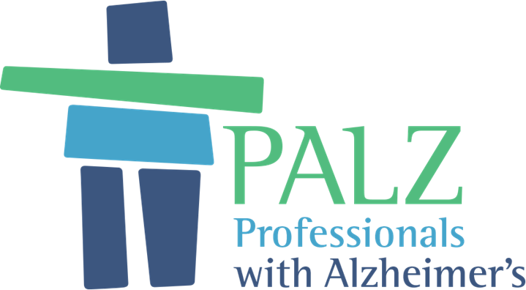
Registered Charity Number 1190292. Website: www.palzuk.org.uk

LOOKING TO HELP THOSE LIVING WITH ALZHEIMERS OR DEMENTIA FROM OTHER CAUSES?

WANT TO IMPROVE YOUR LOCAL COMMUNITY?

WHY NOT SET UP A LOCAL GROUP WITH THE HELP OF A NEW NATIONAL CHARITY FOUNDED IN SHROPSHIRE?

Index to Contents

Page 3 The Background to PALZ UK
Page 4 Description of the Activities of PALZ UK
Page 5 /6 I Illustration of Potential Contacts to raise Awareness
Page 7 /8 PALZ UK – The Model. Suggested format for Group Meetings
Page 9 Want to Go Ahead? Action List / What Support is Available
Page 10 /11 Appendix 1 Why not Sponsor a Meeting of PALZ UK? Benefits to Sponsors
Page12 Appendix 2 Personal Data / GDPR Form
Page 13 / 14 Participants Details with Privacy Notice

The background to PALZ UK…
PALZ UK (based on the model of PALZ Global in Australia) began in March 2018 in Shropshire after a lot of initial work raising awareness of the new organisation. PALZ UK aims to provide those, from challenging work backgrounds in the early stage of dementia with stimulating activity, in a work type environment, with others of a similar background.
In Shropshire; in non-Covid times, the group meets every two months at the Shropshire Conference Centre, when there is a talk by a high calibre speaker. Before; after and indeed often part way through the talk, there is coffee and cake and an opportunity for discussion and socialising. Some stay on for lunch in the excellent dining room.
PALZ is providing a service which has been lacking; to those from challenging and demanding jobs, who are now living with Alzheimer’s or dementia from other causes. It concentrates on “Who you are and not what you have” and focuses on highly intelligent, interesting and interested people who just happen to have dementia.
No one will be turned away. The only eligibility criteria is that the person is in the early stage of dementia, though some may be a little further down the road, but still be able to be stimulated and challenged by the talks.
Supporters are welcome and many couples have formed close relationships as they are on the same journey and have a true understanding of the journey each are on.
It soon became apparent here in Shropshire that there was relief that PALZ had been set up. Remarks were made such as “This is just what we have been looking for” and “It is wonderful to be treated as normal”
Later feedback includes:-
This is the first time I have seen my husband smile in weeks
People at PALZ understand that just because your memory isn’t good, you still have a brain!
After two years an application was made to the Charity Commission and 8 days later, PALZ became a UK wide charity ready to roll out across the UK.
PALZ UK is a Charitable Incorporated Organisation and has a Constitution which is on the website as is the Business Plan in Resources.

Description of the Activities of PALZ UK
PALZ UK …
- Provides stimulating talks, in a work type environment, for those in the early stage of dementia (from whatever cause) together with their supporters, including opportunities for questions and discussion.

- Arranges group visits to places of interest.

- Creates opportunities for social interaction with like minded people, from challenging and demanding work backgrounds, who just happen to have dementia.

Below is the object clause in our constitution:

For the public benefit, the relief and assistance of people who have held challenging and demanding jobs and who are now living with Alzheimer's (or dementia from other causes), with a social environment of peer support and mental challenge which will provide self-respect, confidence, mental stimulation, and involvement to those who attend and their supporters.

Illustration of Potential Contacts

Who should I contact to raise awareness of PALZ UK?
Awareness has been raised in Shropshire by contact with the following organisations listed below. The details are illustrations of the type of organisations and services that may be established in your area.

- Shropshire Clinical Commissioning Group and the Director of services for dementia.
- Shropshire Social services and Andy Begley, Executive director adult services at Shropshire Council and Michelle Davies, Service manager commissioning and governance at Shropshire Council, together with James Warman, their Assistive Technology and Telecare coordinator.
- Members of the medical profession including Professor Tony Elliot, Consultant psychiatrist, Clinical director for older people and professor at Chester University, who subsequently became the medical director for PALZ.
- The Dementia clinical specialist nurse at the Shropshire and Telford Hospital Trust.
- Dr Suzy Thompson, Consultant in Older patients care at the Shrewsbury and Telford Hospital Trust and Dr David Rice at the Shropshire and Staffordshire NHS trust.
- Mr Jeremy Hughes CEO of Alzheimers UK (and subsequently with Tim Beanland the Head of Knowledge Management at Alzheimers UK).
- Local Alzheimer’s Societies.
- Age UK Shropshire Telford and Wrekin.
- Care coordinators within the GP practices in Shropshire.
- Shropshire Partners in Care.
- The CEO of Parkinson’s UK.
- The University of Shrewsbury.
- The Memory Clinic personnel.
- The Admiral Nurses, Telford (there being none in Shrewsbury).
- The Maysi project personnel at the Mayfair Centre in Church Stretton.
- Helping Hands in Ludlow - being a newly set up charity coordinating various services.
- The Social Prescribing Team in Shropshire.
- Carers’ organisations including Telford Carers and Carers Trust 4 All in Shrewsbury.
- The Director of Communications at the Shropshire and Telford Hospital Trust.
- The Director of Corporate services at the Shrewsbury and Telford Hospital Trust.
- Various rotary clubs.
- U3A –Still ‘work in progress’.

*Important:
As well as the above, information about PALZ has been disseminated by Liz Holdsworth by speaking on Radio Shropshire on three occasions; and giving talks to local groups. Press releases have appeared in the local press and information has been sent to all lawyers on the SFE (Solicitors for the Elderly) forum throughout the UK, approximately 1,500 in all.

Laminated posters and glossy (but compact) fliers have been placed in many different locations including GP services, libraries and lawyers’ offices. Examples of these are located in the Resources Section of the website

https://palzuk.org.uk).

PALZ the Model
PALZ is a support group, with a goal to give dignity, social interaction, mental stimulation, and, importantly, to delay the need to access community health services.
Each PALZ group meets every two months in a work type environment such as a Conference centre, with high calibre speakers, speaking to their peers.
Each group should have a Facilitator, who can attend each meeting for administrative purposes and also an assistant Facilitator as a backup.
Date of meeting. It is suggested that the same day of the month is chosen which is easy to remember. For example, the Shropshire group meets on the third Tuesday of every other month starting in January, then March, May, July, September and November.
The session lasts approximately two hours from 10 am until 12 noon, since morning is better for participants. As friendships form some may join others for lunch at the venue or nearby.
The timing can be flexible, but it is suggested that refreshments are available when the participants arrive and that talks of about an hour’s duration are delivered in two halves with an opportunity for more refreshments and social mingling halfway.
At the end there should be time for questions and discussion and perhaps an opportunity to share life stories, though this may need to be in a separate meeting.
Someone clearly needs to introduce the speaker and thank them at the end of the morning and perhaps, present a token gift if the speaker is kind enough not to request a fee. Shropshire has found that many speakers are happy with a donation to particular charities of their choice.
It may be that the Facilitator is undertaking these tasks, but equally a member of the committee who may also be a participant would be happy to do so.
It is suggested that there should be a committee to share the load and that there be appointed a Treasurer, Secretary, a person to spearhead accessing speakers, together with someone spearheading approaching businesses for sponsorship of the meetings. A document to encourage Sponsorship is attached (Appendix 1) and a list of those which have sponsored the Shropshire group can be seen on the website.
Group members are encouraged to meet socially in the intervening month, and it may be that a visit is appropriate following a meeting. The Shropshire group had a talk by a local prize-winning Organic Dairy farmer, and this was followed by a much-enjoyed visit to the farm.
In the UK there will be no requirement to become a member or pay a membership fee. The only financial consideration will be a request for a contribution towards refreshments, we suggest a minimum £2.50, but this is flexible.
Ideally the potential participant or their supporter will contact the facilitator of the group prior to the next meeting so that he or she can, in advance, become better acquainted with the facilitator and learn about the group and what to expect. However, some people may hear about the group and come directly to a meeting.
A form is available to enter details of the new participant including name, address, email and telephone numbers of both the new participant and their supporter. (Appendix 2). There is also a form to sign to comply with General Data Protection Regulations (GDPR) (Appendix 3)
Suggested format for group meetings:
- Participants arrive any time from 9.40 am so it is a good idea to make sure that refreshments are laid out in an easily accessible place and that you have
volunteers/committee members to assist and to provide a warm welcome.
- A reception table needs to be in place to record attendance, and to provide forms for new participants.
- Name badges should be provided. This assists not only the participants but also the volunteers.
- The speaker arrives and should be welcomed.
- Talk starts at about 10am and the Guest Speaker is publicly introduced.
- Halfway, a break for refreshments, comfort stops or conversation.
- Second half of the talk followed by questions and discussion.
- The speaker is thanked and given a token present if appropriate or group advised of the charity to which a donation is to be made.
- Conversation amongst the participants.
- Future events outlined.
DO YOU WANT TO GO AHEAD?

ACTION LIST
- Find 2 or 3 volunteers to set up the group
- Locate a suitable venue, preferably with little or no cost
- Follow the suggested routes for raising awareness in Shropshire as set out.
- Contact possible local speakers (U3A are a good source)
- Promote the group through methods used in Shropshire

WHAT SUPPORT IS AVAILABLE FOR THIS?
- Help is available with all aspects of setting up a group from experts who have already done this. You are part of a UK wide charity and have all the support it can offer.
- An expenses paid visit can be made to Shropshire to see a PALZ group in action, or a representative from the Trustees of PALZ will come to you to discuss the way forward.
- There is promotional template material (See flyer and poster).
- Financial support may be provided to set up a group.
Contact: E: info@palzglobal.org.uk

Appendix 1
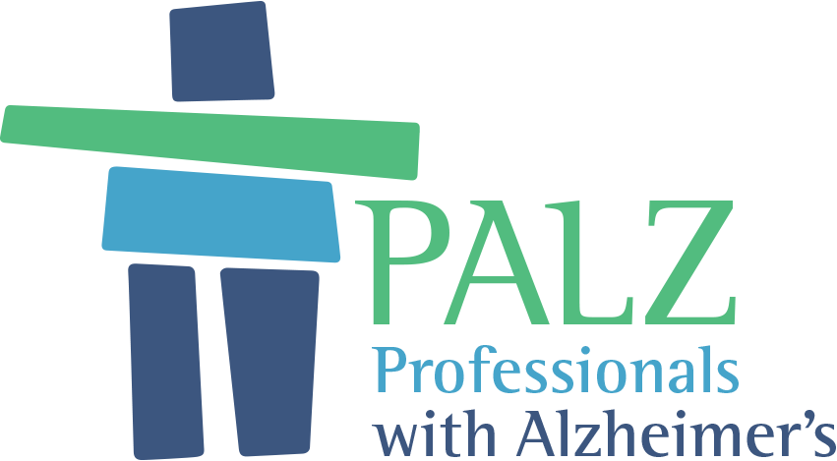

WHY NOT SPONSOR A MEETING OF PALZ UK?

PALZ UK (palzuk.org.uk) began in March 2018 in Shropshire after a lot of work raising awareness of the organisation. PALZ UK aims to provide those in the early stage of dementia with stimulating activity, in a work type environment, with others of similar background.
Groups meet every two months when there is a talk by a high calibre speaker. Before, after and indeed often part way through the talk, there are refreshments and an opportunity for discussion and socialising. Some may join others for lunch.
PALZ is providing a service which has been lacking, to those from challenging and demanding jobs, who are now living with Alzheimer’s or dementia from other causes. It concentrates on “Who you are and not what you have” and focuses on highly intelligent, interesting and interested people who just happen to have dementia.
No one is turned away. The only eligibility criteria is that the person is in the early stage of dementia, though some may be a little further down the road, but still be able to be stimulated and challenged by the talks.

PALZ UK – Shropshire…
It soon became apparent in Shropshire that there was relief that PALZ had been set up. Remarks were made such as “This is just what we have been looking for” and “It is wonderful to be treated as normal”
PALZ UK has become a National Charity number 1190292 and is being rolled out across the UK.
We are supported by Business / Commercial Sponsorship and in Shropshire have been grateful to the many local businesses which have sponsored our meetings.
We ask sponsors to donate £250 to cover each meeting. Sponsorship would also be welcome from social or charitable organisations. This aims to cover costs relating to premises, speakers, the website and printing of posters, flyers and other organisation related printing. All current sponsors are shown on the sponsorship section of the website, https://palzuk.org.uk

The Shropshire group has proved very successful, and the next step is to roll out the organisation across the UK, so that others in different parts of the UK can benefit.

What are the benefits to Sponsors of PALZ UK?

- Acknowledgement on the PALZ UK website in the Sponsors section.

- The opportunity for advance publicity to highlight sponsors support prior to the meeting.

- Opportunity to speak at the sponsored meeting and to meet participants.

- Invitations to any upcoming events to thank all sponsors, at which we would expect there to be a presence of local dignitaries, radio and press.

- Presentation of a framed certificate to display in sponsor’s offices.

- Lastly, but not least, the chance to help those in difficult and challenging circumstances to be treated with dignity and respect, recognising their worth as highly intelligent people, who have made huge contributions to society and are now facing possible the biggest challenge of their lives.

PALZ UK Participants: Personal Data

We hold the following personal information about you in accordance with the EU General Date Protection Regulation (GDPR) and the Privacy Notice overleaf.

Title:
First name:
Surname:
Preferred name:
Address:

Phone number(s):
Email address(es):

I confirm that I am happy for PALZ UK to hold my above personal data and to use it for the purposes described in the Privacy Notice overleaf

Signed……………………………………………………………………………

Date……………………………………………………………………………….

Privacy Notice: Participants in Activities
It is important to us that you understand and are happy with how we use your information. Please take time to read this Privacy Notice in full.
Data Subjects
are people like you, who take part in our activities.

What we do with your personal data?
We use your personal data to help us organise the sort of activities that you like to come to, and to keep you informed about those activities. We can do this because we have a legitimate interest in knowing who is participating in our activities and in being able to share with them details of our activities (including any changes) and related activities.

Your right to withdraw consent at any time
You can tell us that you no longer wish us to use your data in this way and, if you do, we must stop using it as soon as is reasonably practical

Your right to require the erasure of your data (right to be forgotten)
If you no longer wish us to have or use your data you can tell us to remove your data completely from our records and we must do so as soon as is reasonably practical

Who gets to see your personal data?
We only share your personal data with other people when it is necessary to do so in order for us to run our activities efficiently and in the way that you would like.
We do not share your data with anyone else.

How long do we keep your personal data?
We only keep your personal data while you come to our activities, either regularly or from time-to-time.
If we have not seen you at one of our activities for 2 years we will delete your data.

We do not transfer your personal data to other countries

The existence of each of your rights
Under the General Data Protection Regulation you have the following rights:
a) to be told about what data we have, how and what we use it for, and who we share it
with (as we are doing in this Privacy Notice);
b) to be given access to your personal data;
c) to have any errors corrected or incomplete data completed;
d) to stop us using your data if you think our use is unjustified or the data are
inaccurate.

Your legal obligation
You are under no legal obligation to give us your personal data if you do not wish to.

The existence of automated decision making, including profiling
PALZ UK does not use computers to analyse your data in order to make computer decisions about what communications PALZ UK should, or should not, send to you.

The right to complain to the UK Information Commissioner’s Office:
if you are dissatisfied with the way that PALZ UK is collecting, holding, processing and using your personal data you are entitled to complain to the Information Commission.

Identity and contact details of the controller.
PALZ UK Data Controller is the Chair of PALZ UK, Liz Holdsworth
The Controller can be contacted via: Liz Holdsworth
Phone: 01743 718495; e-mail: lizaholdsworth@hotmail.com

